Chatgpt reference: <https://chatgpt.com/share/68d3e3d8-41f4-800b-b5cf-b7fbcbb37deb>

**Developer Documentation – Product Attributes & Variants**

**1. Overview**

In our e-commerce backend, a **Product** can have multiple **Attributes** (e.g. Color, Size, Material).  
Each **Product Variant** represents a unique combination of attribute values (e.g. Red + L).

We use the following tables:

* **product** → Base product information.
* **attribute** → Defines attribute types (e.g. Color, Size).
* **product_variant** → Stores unique variant rows for each combination of attributes, with price and stock.
* **product_variant_attribute** → Junction table linking variants to their attributes and values.

We **do not use an attribute_value table**. Instead, values are stored directly in product_variant_attribute.value as JSON (to support multilingual values).

## 2. Workflow / User Journey

### Step 1: Admin defines Attributes (Global)

* Admin creates reusable attributes in **attribute** table.

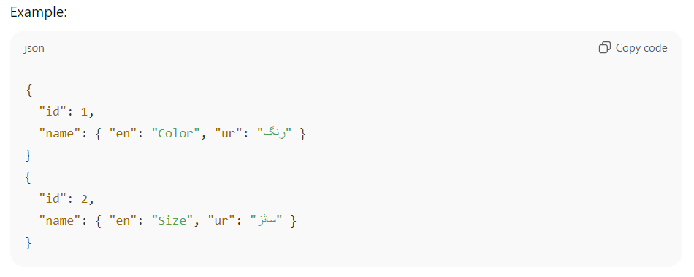

### Step 2: Create a Product

* A base product is created in **product** table.

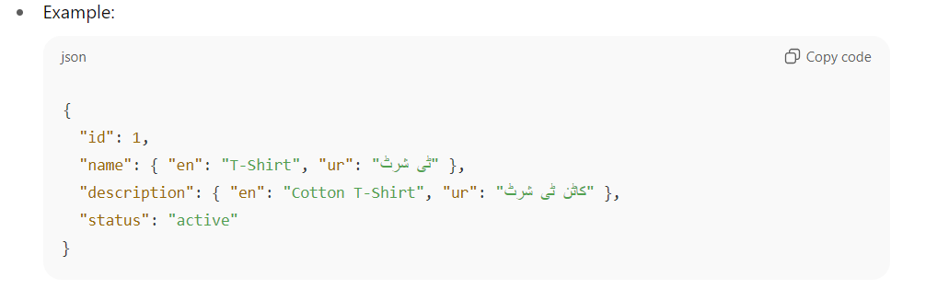

### Step 3: Frontend Sends Attribute Selections

When creating a product, the frontend fetches available attributes (attribute table).  
The user selects possible values (e.g. Color = [Red, Blue], Size = [S, M, L]).

Payload sent from frontend:

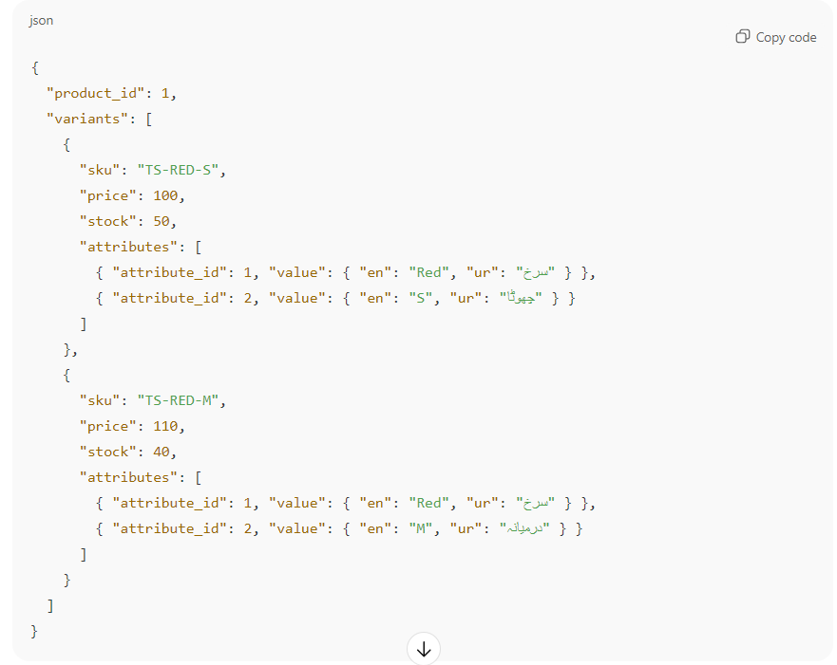

### Step 4: Save Variants

Each variant is inserted into **product_variant**:

| **id** | **product_id** | **sku** | **price** | **stock** | **status** |
| --- | --- | --- | --- | --- | --- |
| 1 | 1 | TS-RED-S | 100 | 50 | active |
| 2 | 1 | TS-RED-M | 110 | 40 | active |

### Step 5: Save Variant Attributes

Each variant’s attributes are stored in **product_variant_attribute**:

| **id** | **product_variant_id** | **attribute_id** | **value (JSONB)** |
| --- | --- | --- | --- |
| 1 | 1 | 1 (Color) | {"en":"Red","ur":"سرخ"} |
| 2 | 1 | 2 (Size) | {"en":"S","ur":"چھوٹا"} |
| 3 | 2 | 1 (Color) | {"en":"Red","ur":"سرخ"} |
| 4 | 2 | 2 (Size) | {"en":"M","ur":"درمیانہ"} |

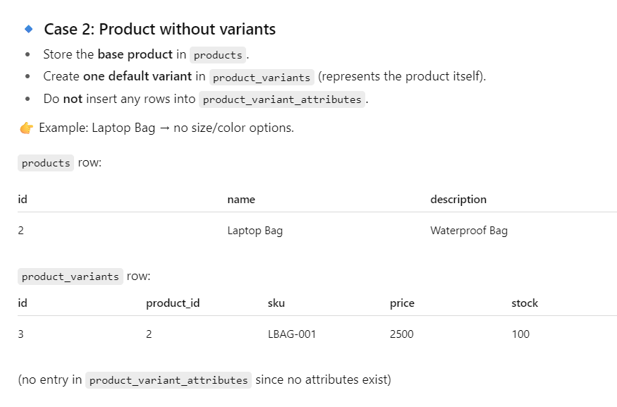

For product having no variant